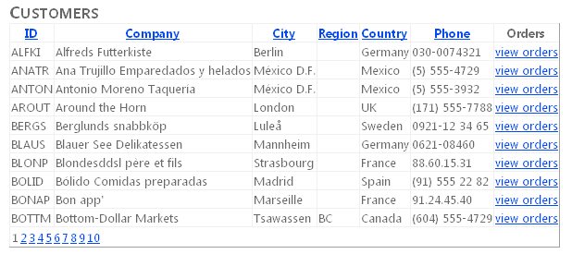

Select a view order and the orders page is shown

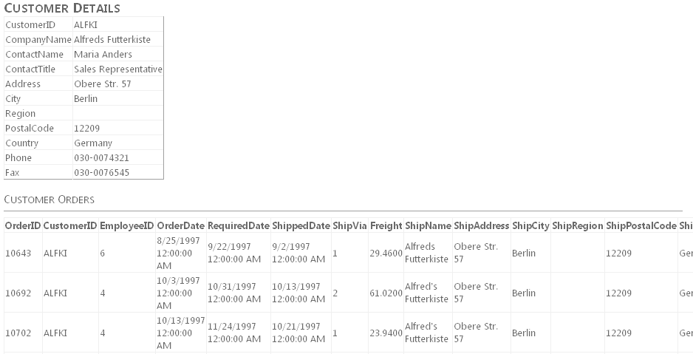

Exercise 1 Creating the Website and Defining the Entity Model

In this exercise, you create a new website and define the Entity Model.

1. Create a new website

2. Add the northwnd.mdf file to your App_Data directory.

3. Add a new ADO.NET Entity Data Model to your website. Name this model Northwind.edmx. When prompted, allow Visual Studio to add the model to the App_Code directory.

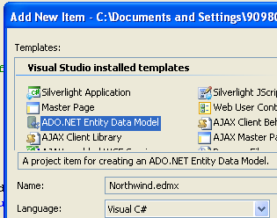

4. Using the Entity Data Model Wizard, select Generate from database on the first step and click Next.

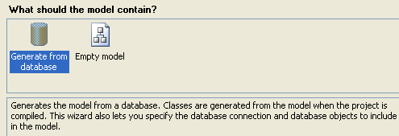
5. On the next page, select the northwnd.mdf data file. Make sure to select the check box to save the connection string in the Web.config file. Name this connection string NorthwndEntitiesCnn and click Next.

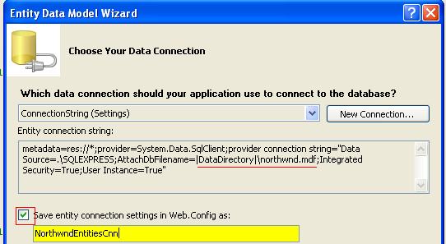

6. On the next page, select the Customers, Order Details, and Orders tables. Make sure that both check boxes are selected, and set the Model Namespace to NorthwndModel.

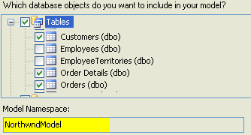

7. Rename items in the model to better identify them.
- Select the Order_Detail entity in the model, right-click it, and choose Rename.
- Rename the entity to OrderDetail.

- Then select the Order_Details navigation property from the Order entity and rename it to OrderDetails.

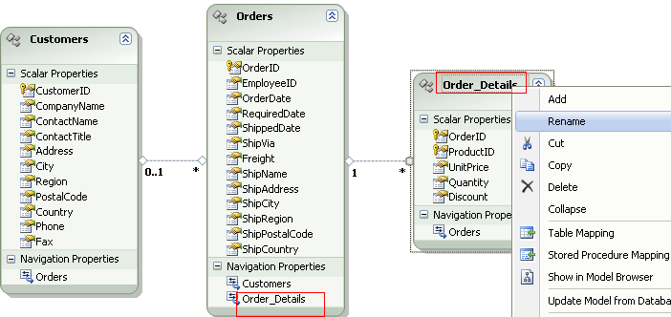

8. Save and close the model.

Exercise 2 Binding to the EntityDataSource Control

In this exercise, you create a webpage that defines an EntityDataSource that will be used to work with the entity model created in the previous exercise.

1. Continue editing the project you created in the previous exercise.

2. Open the Default.aspx page. Set the title to Customers.

<head runat="server">
<title></title>
<h2>Customers</h2>
</head>

3. In Design view, drag an EntityDataSource control onto the page from the Data tab of the Toolbox. This control will be used to expose a list of customers in the database.

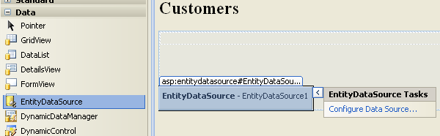

4. Click the smart tag in the upper-right corner of the EntityDataSource control to open the EntityDataSource Tasks list.

5. Select Configure Data Source to open the Configure Data Source Wizard.

a. On the first page of the wizard, from the Named Connection list, select NorthwndEntitiesCnn.

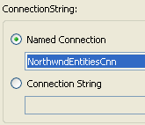
b. On the second page of the wizard,
- Select the Customers EntitySetName.
- Set the Select fields to CustomerID, CompanyName, City, Region, Country, and Phone.

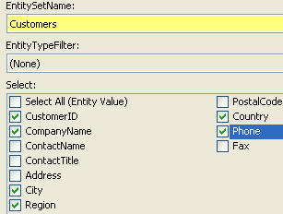

c. Finish the wizard, and switch to Source view for your page. Edit the EntityDataSource markup to include
- AutoPage
- AutoSort
- OrderBy statement to order the results by CompanyName ( it.CompanyName )

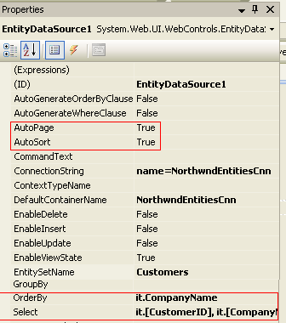

<asp:EntityDataSource ID="EntityDataSource1" runat="server"
ConnectionString="name=NorthwndEntitiesCnn"
DefaultContainerName="NorthwndEntitiesCnn"
EnableFlattening="False"
EntitySetName="Customers"
AutoPage="true"
AutoSort="true
OrderBy="it.CompanyName"
Select="it.[CustomerID], it.[CompanyName], it.[City], it.[Region], it.[Country], it.[Phone]">
</asp:EntityDataSource>

6. Add a GridView control to the page. Set the DataSourceID property to point to the EntityDataSource created previously.

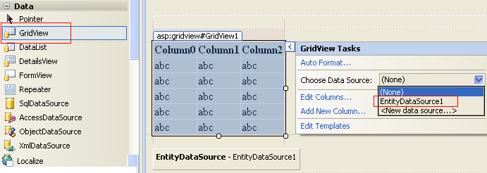

7. Define bound columns and change the HeaderText for each field in the result set.

DataField | HeaderText | SortExpression
CustomerID | ID | CustomerID
CompanyName | Company | CompanyName
City | City | City
Region | Region | Region
Country | Country | Country
Phone | Phone | Phone

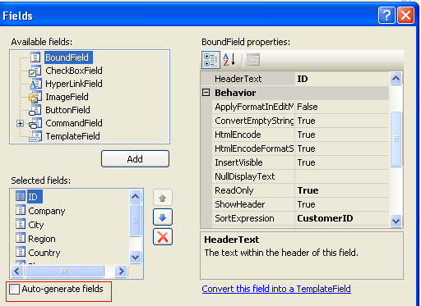

8. Enable AllowPaging and AllowSorting.

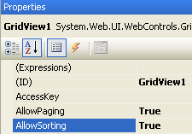

9. Add a HyperLinkField to the GridView to call orders.aspx and pass the customer ID as a query string parameter.

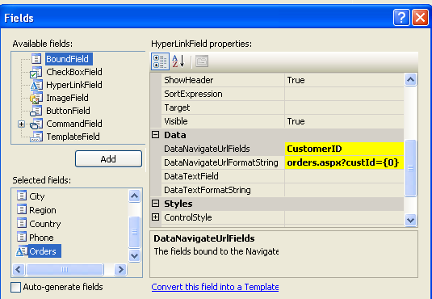

Your GridView markup should look as follows.

<asp:GridView ID="GridViewCustomers" runat="server" AllowPaging="True"
AllowSorting="True" AutoGenerateColumns="False"
DataSourceID="EntityDataSource1">
<Columns>
<asp:BoundField DataField="CustomerID" HeaderText="ID" ReadOnly="True" SortExpression="CustomerID" />
<asp:BoundField DataField="CompanyName" HeaderText="Company" ReadOnly="True" SortExpression="CompanyName" />
<asp:BoundField DataField="City" HeaderText="City" ReadOnly="True" SortExpression="City" />
<asp:BoundField DataField="Region" HeaderText="Region" ReadOnly="True" SortExpression="Region" />
<asp:BoundField DataField="Country" HeaderText="Country" ReadOnly="True" SortExpression="Country" />
<asp:BoundField DataField="Phone" HeaderText="Phone" ReadOnly="True" SortExpression="Phone" />
<asp:HyperLinkField DataNavigateUrlFields="CustomerID" DataNavigateUrlFormatString="orders.aspx?custId={0}"
HeaderText="Orders" Text="view orders" />
</Columns>
</asp:GridView>

B) CREATE ORDER PAGE

10. Create the ORDERS PAGE Add an Orders.aspx page to your site.

11. Add an EntityDataSource control to the page.

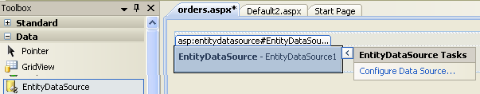

12. In properties

- Set EntitySetName to Customers
- Set Include to Orders

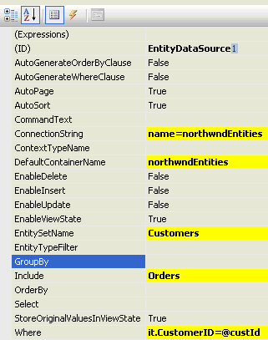

13. Define a Where clause type it.CustomerID=@custId

14. Click the button and set the parameter. Select a customer by a specific ID. Set the ID as a QueryStringParameter.

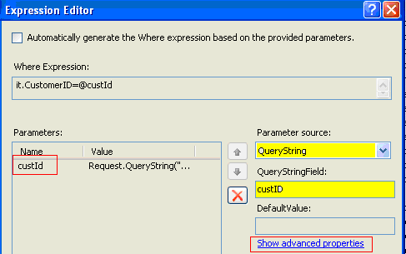

15. Click Show advanced properties and select String
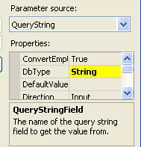

The following markup shows an example.

<asp:EntityDataSource ID="EntityDataSource1" runat="server"
ConnectionString="name=NorthwndEntitiesCnn"
DefaultContainerName="NorthwndEntitiesCnn"
EntitySetName="Customers"
EnableFlattening="False"
Include="Orders"
Where="it.CustomerID=@custId">
<WhereParameters>
<asp:QueryStringParameter
DbType="String"
Name="custId"
QueryStringField="custID" />
</WhereParameters>
</asp:EntityDataSource>

11. Next, add a DetailsView control to the page and name it DetailsViewCust. In Design view, use the smart tag to set the data source to the EntityDataSource set previously.

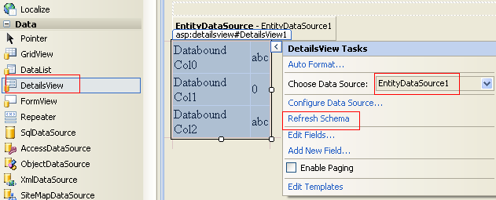

Select Refresh Schema from the same smart tag task list to generate columns bound to the data source.

C) BOUND UPPER DETAIL VIEW TO THE GRID VIEW

12. Add a GridView control under the DetailsView and name it GridViewOrders.

This will be used to show custom orders. You cannot, at present, bind this to the included collections of the EntityDataSource by using markup. Instead, you must write some code.

13. Add an event handler for the DetailsViewCust DataBound event. This event fires when the DetailsView control has been bound to data. You can use it to pull the bound Customer from the control and use its Orders collection for the GridView control. Your code should read as follows.

Use the Model Namespace define in this step: (6)

Sample of Visual Basic Code

Protected Sub DetailsViewCust_DataBound( ByVal sender As Object, ByVal e As System.EventArgs) Handles DetailsViewCust.DataBound
Dim cust As NorthwndModel.Customer = CType(DetailsViewCust.DataItem, NorthwndModel.Customer)
Me.GridViewOrders.DataSource = cust.Orders
Me.GridViewOrders.DataBind()
End Sub

Sample of C# Code

protected void DetailsViewCust_DataBound(object sender, EventArgs e)
{
NorthwndModel.Customers cust = (NorthwndModel.Customers)DetailsViewCust.DataItem;
if (cust != null)
{
this.GridViewOrders.DataSource = cust.Orders;
this.GridViewOrders.DataBind();
}
}

If the following message appears when doing the following instruction

NorthwndModel.Customers cust = (NorthwndModel.Customers)DetailsViewCust.DataItem;

Unable to cast object of type 'System.Web.UI.WebControls.EntityDataSourceWrapper' to type 'NorthwndModel.Customers'.

In the You need to include EnableFlattening="False" In the EntityDataSource, but this is only possible in VS 2010, not in VS 2008

Select a view order and the orders page is shown

D) IN ONE PAGE

If you want to include everything in the first page

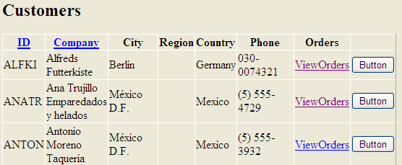

1. Include the button

<asp:ButtonField runat="server"
Text="Button"
CommandName="DetalleOrdenes"
ButtonType="Button" />

2. Include the code

protected void GridView1_RowCommand(object sender, GridViewCommandEventArgs e)
{
if (e.CommandName == "DetalleOrdenes")
{
int currentRow = int.Parse(e.CommandArgument.ToString());
string custId = GridView1.Rows[currentRow].Cells[0].Text.ToString();
string strSQL = "select * from orders where custId ="+ custId;

SqlConnection conn = new SqlConnection(System.Configuration.ConfigurationManager.AppSettings["conString"]);

SqlCommand cmd = new SqlCommand(strSQL, conn);

SqlDataAdapter SqlAdap = new SqlDataAdapter(cmd);
System.Data.DataTable dt = new System.Data.DataTable("Data1");

SqlAdap.Fill(dt);

GridViewOrders.DataSource = dt;
GridViewOrders.DataBind();
}
}

Otra alternative mas sencilla es con EntityDataSource

protected void GridView1_RowCommand(object sender, GridViewCommandEventArgs e)
{
if (e.CommandName == "DetalleOrdenes")
{
int currentRow = int.Parse(e.CommandArgument.ToString());
Label1.Text = GridView1.Rows[currentRow].Cells[0].Text.ToString();
}
}

Al momento de actualizar Label1 se carga los datos si se le asigna un EntityDataSource al nuevo GridView y se le asigna el Where que se dispare al momento de actualizar el Control Label1.

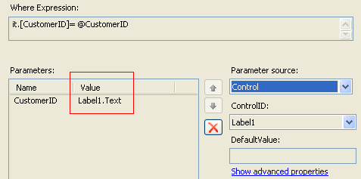

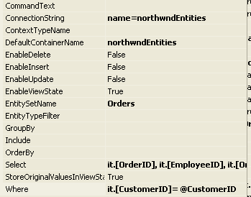

Pero la mejor alternativa es con una variable session Session[“CustomerID”]

